

CHRIST (Deemed to be University) Bengaluru – 560029
School of Business Management
Pune – Lavasa Campus

MBA 342B – Python for Data Analysis (PDA)
CIA -III PROJECT REPORT

(Topic : Sentiment Analysis and Data Visualization of NIFTY 50 using Python and Machine Learning)

Submitted By: Khushi Mathur
Register No: 25121022
Class: 3MBA A PLC
Course Code & Name: MBA 342B – Python for Data Analysis (PDA)
Campus: Pune Lavasa Campus
Submitted To: Prof. Himani Saraswat

1. INTRODUCTION
The stock market is one of the most important indicators of a country’s economic condition. Daily fluctuations in stock prices reflect investor confidence, company performance, economic trends, and market sentiment. NIFTY 50 is one of India’s leading stock market indices representing the top 50 companies listed on the National Stock Exchange (NSE) of India.
Understanding market sentiment is useful for investors, traders, and analysts because it helps identify whether the market mood is optimistic or pessimistic. Positive sentiment usually indicates growth expectations, while negative sentiment indicates uncertainty or decline.
This project focuses on analyzing historical NIFTY 50 market data using Python. By comparing opening and closing prices, sentiment is classified as Positive or Negative. Data visualization techniques are then used to present trends clearly, and a machine learning model is implemented to classify sentiment automatically.

2. PROBLEM STATEMENT
Investors often face difficulty understanding daily market behavior and sentiment due to continuous fluctuations in prices and large volumes of data.
Traditional manual analysis is time-consuming and less effective.
Therefore, there is a need for an automated system using Python and Machine Learning that can analyze historical NIFTY 50 data, classify market sentiment, and present results through effective visualizations.

3. OBJECTIVES
- To analyze historical NIFTY 50 stock market data
- To classify daily market sentiment as Positive or Negative
- To visualize sentiment trends using charts and graphs
- To implement machine learning for sentiment classification
- To understand investor behavior through market movement patterns

4. DATASET DETAILS
Dataset Used: NIFTY 50 Historical Dataset
Period Covered: 15 April 2025 to 15 October 2025
Variables in Dataset:
- Date
- Open
- High
- Low
- Close
- Shares Traded
- Turnover (₹ Cr)

5. CHALLENGES FACED
- Stock market data changes daily and is volatile
- Noise in market prices due to random movement
- Data cleaning required for numeric conversion
- Limited direct sentiment labels in stock dataset
- Choosing suitable machine learning model
- Visualizing large data in readable format

6. METHODOLOGY
Machine Learning Based Methodology using Python
Step 1: Data Collection
Historical NIFTY 50 market data was used for the project.
Step 2: Data Cleaning
- Removed missing values
- Converted numeric columns
- Formatted dates properly
Step 3: Sentiment Creation
Sentiment labels were generated using:
- If Close > Open → Positive
- If Close < Open → Negative
Step 4: Data Visualization (DV)
Charts used:
- Pie Chart
- Bar Chart
- Timeline Scatter Plot
- Open vs Close Trend Graph
Step 5: Machine Learning Implementation
A Logistic Regression model was used to classify sentiment.
Step 6: Performance Evaluation
Accuracy score and confusion matrix were generated.

7. MACHINE LEARNING IMPLEMENTED
Logistic Regression
Logistic Regression is a classification algorithm used to predict categorical outcomes.
In this project, it predicts:
- Positive Sentiment
- Negative Sentiment
Why Logistic Regression?
- Easy to implement
- Fast execution
- Suitable for binary classification
- Good for beginner projects

8. DATA VISUALIZATION ANALYSIS

1. Pie Chart
Displays percentage of positive and negative market days.
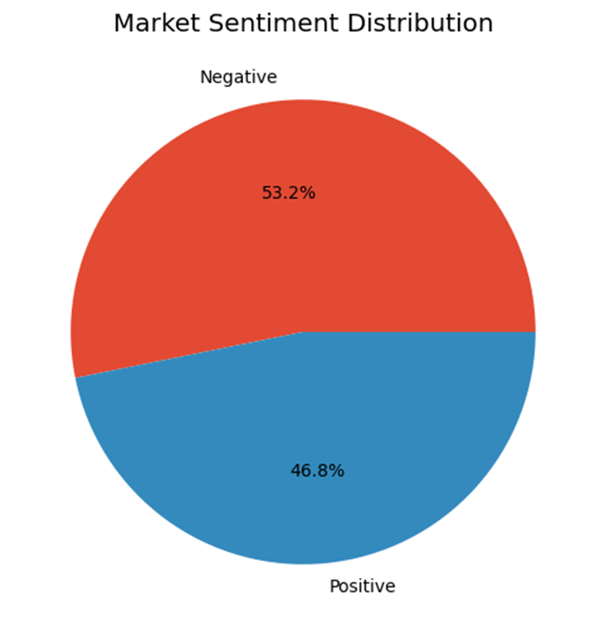

Insight:
Shows whether market was mostly optimistic or pessimistic.

2. Bar Chart
Displays count of sentiment classes.
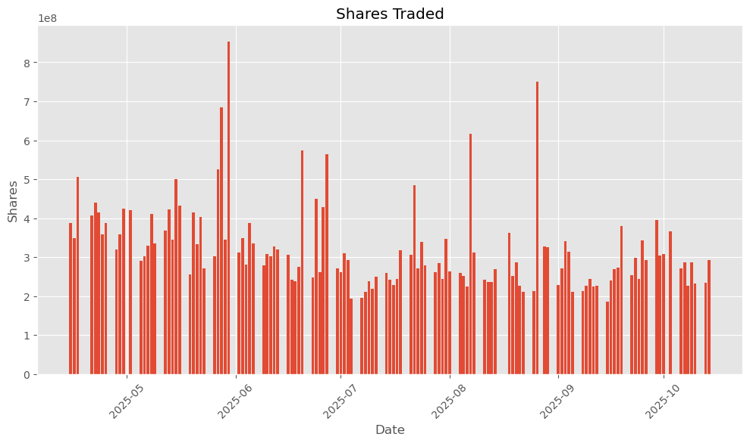

Insight:
Shows frequency of positive vs negative sessions.

3. Timeline Sentiment Graph
Displays market sentiment over time.

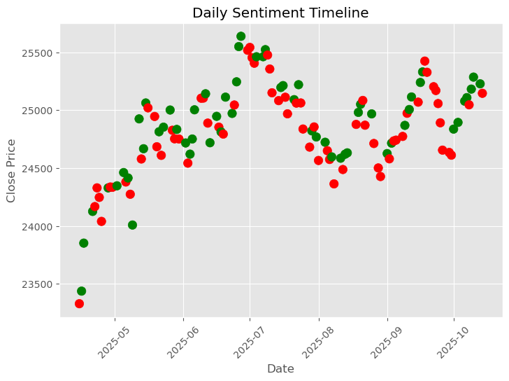

Insight:
Useful to identify bullish and bearish periods.

4. Open vs Close Trend
Compares daily opening and closing prices.
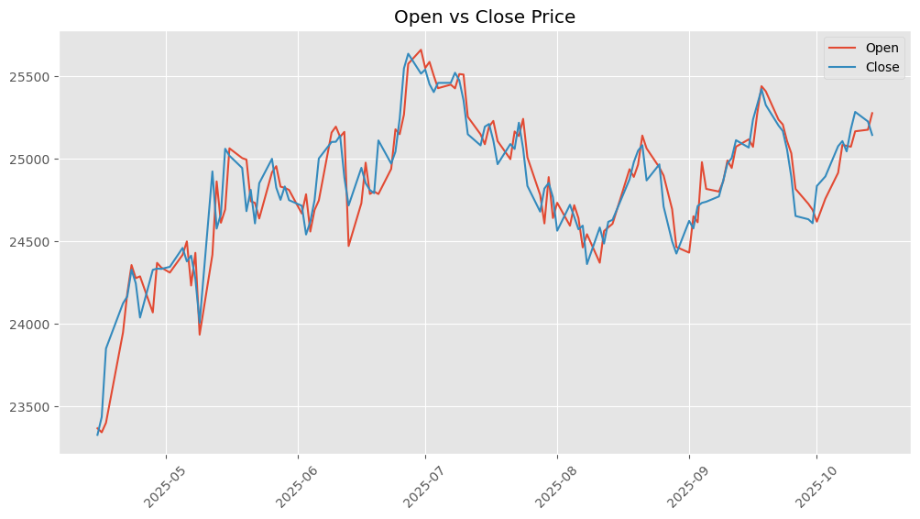

Insight:
Helps analyze intraday sentiment.

5. Correlation Heatmap of NIFTY 50 Features

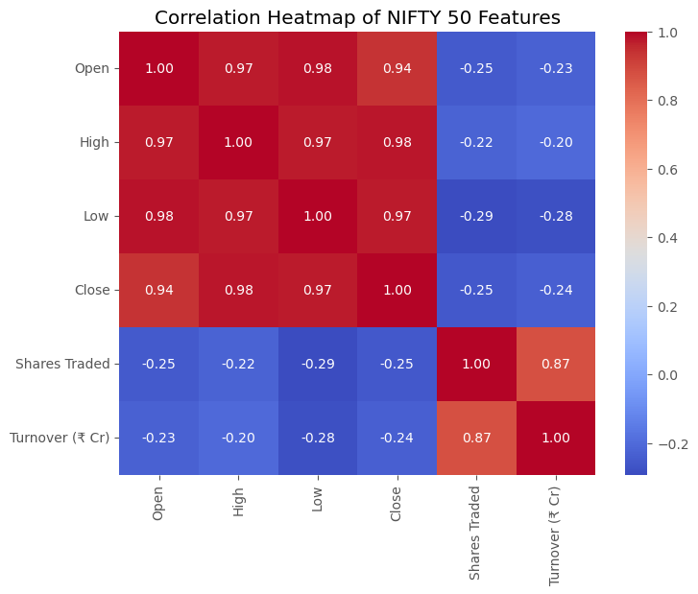

6. Confusion matrix:

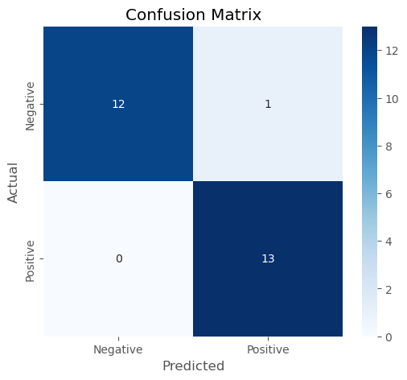

9. ANALYSIS
The analysis of the NIFTY 50 dataset reveals meaningful insights into market behavior and investor sentiment over the selected time period. By comparing opening and closing prices, each trading day was classified as either positive or negative, reflecting bullish and bearish market conditions respectively. The results indicate a fluctuating market trend with alternating periods of positive and negative sentiment, highlighting the inherent volatility of the stock market. Data visualization techniques such as pie charts and bar graphs showed the proportion and frequency of positive versus negative trading sessions, while timeline analysis helped identify patterns and shifts in market mood over time.
The correlation heatmap demonstrated strong relationships among price-related variables such as Open, High, Low, and Close, indicating that these features move closely together and are significant indicators of market trends. The machine learning model, implemented using Logistic Regression, was able to classify market sentiment based on these variables with reasonable accuracy. The confusion matrix provided a detailed evaluation of model performance by showing correct and incorrect classifications, while the precision score indicated the reliability of positive sentiment predictions.
Overall, the analysis confirms that historical market data can be effectively used to understand sentiment patterns and build predictive classification models. Although the model does not guarantee future predictions, it provides valuable insights into market behavior and supports data-driven decision-making.

10. CONCLUSION
The project concludes that Python and Machine Learning can be effectively used to analyze stock market sentiment using historical NIFTY 50 data.
By comparing opening and closing prices, daily sentiment was classified successfully. Data visualizations made the results easier to interpret and helped understand overall market mood.
The project demonstrates that sentiment analysis combined with machine learning is a valuable tool for market analysis and decision-making.

11. FUTURE SCOPE
- Add real-time stock data
- Use news headline sentiment analysis
- Build live dashboard
- Use advanced models like Random Forest, XGBoost, LSTM
- Generate Buy/Sell recommendations

12. TOOLS USED
- Python
- Jupyter Notebook
- Pandas
- NumPy
- Matplotlib
- Scikit-learn

DASHBOARD PRESENTATION:

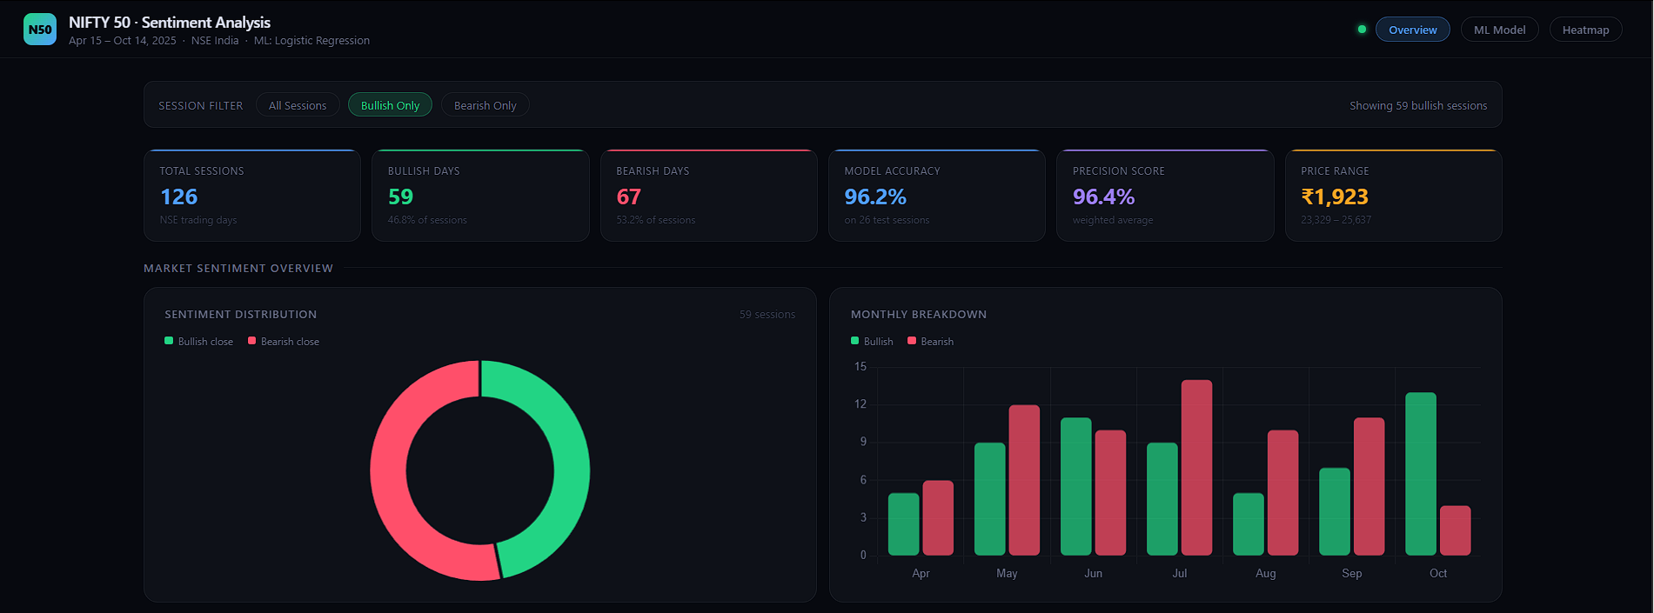

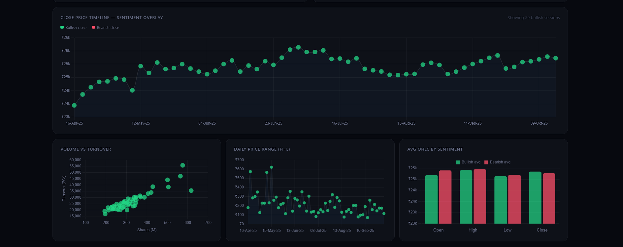

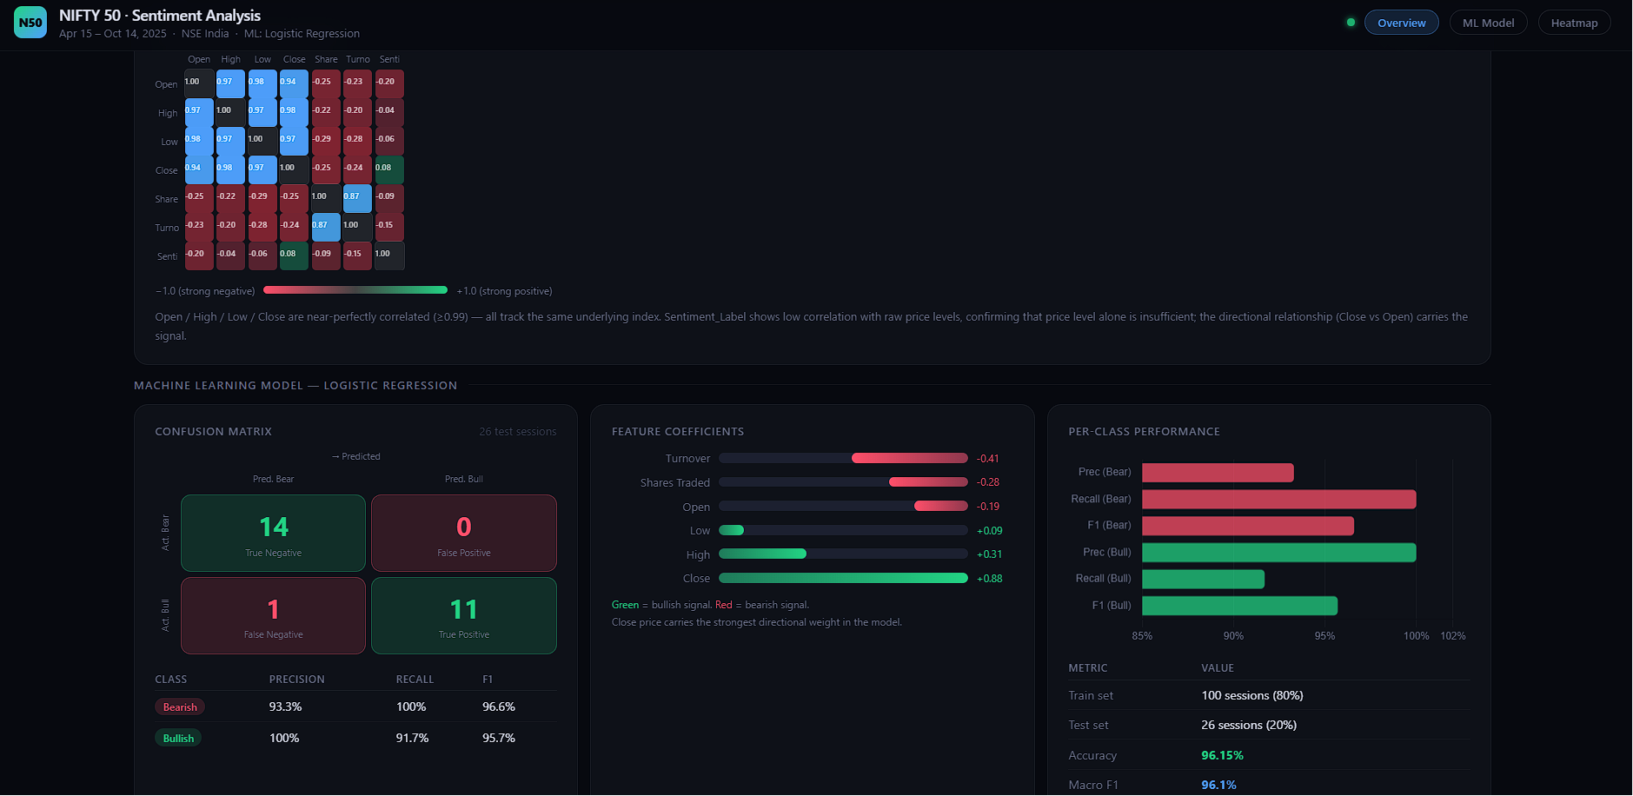

ANNEXURE:
Python code-
import pandas as pd
import numpy as np
import matplotlib.pyplot as plt
from sklearn.model_selection import train_test_split
from sklearn.linear_model import LogisticRegression
from sklearn.metrics import accuracy_score, classification_report, confusion_matrix

# Load Dataset
df = pd.read_csv(r"C:\Users\Khushi Mathur\Downloads\NIFTY 50-15-04-2025-to-15-10-2025 python dataset.csv")

# Clean column names
df.columns = df.columns.str.strip()

print("Columns:")
print(df.columns)

# Remove commas and convert numeric columns
numeric_cols = ['Open', 'High', 'Low', 'Close', 'Shares Traded', 'Turnover (₹ Cr)']

for col in numeric_cols:
df[col] = df[col].astype(str).str.replace(',', '')
df[col] = pd.to_numeric(df[col], errors='coerce')

# Convert Date
df['Date'] = pd.to_datetime(df['Date'], format='%d-%b-%y', errors='coerce')

# Remove missing values
df.dropna(inplace=True)

# Create Sentiment Labels
df['Sentiment'] = np.where(df['Close'] > df['Open'], 'Positive',
np.where(df['Close'] < df['Open'], 'Negative', 'Negative'))

# Features
X = df[['Open', 'High', 'Low', 'Close', 'Shares Traded', 'Turnover (₹ Cr)']]
y = df['Sentiment']

# Train Test Split
X_train, X_test, y_train, y_test = train_test_split(
X, y, test_size=0.2, random_state=42
)

# Model
model = LogisticRegression(max_iter=2000)
model.fit(X_train, y_train)

# Prediction
pred = model.predict(X_test)

# Accuracy
print("Accuracy Score:", accuracy_score(y_test, pred))
print("\nClassification Report:\n", classification_report(y_test, pred))
print("\nConfusion Matrix:\n", confusion_matrix(y_test, pred))

# ------------------------------
# DATA VISUALIZATION
# ------------------------------

# 1 Sentiment Pie Chart
plt.figure(figsize=(6,6))
df['Sentiment'].value_counts().plot(kind='pie', autopct='%1.1f%%')
plt.title("Market Sentiment Distribution")
plt.ylabel("")
plt.show()

# 2 Closing Price Trend
plt.figure(figsize=(12,6))
plt.plot(df['Date'], df['Close'])
plt.title("NIFTY 50 Closing Price Trend")
plt.xlabel("Date")
plt.ylabel("Close")
plt.xticks(rotation=45)
plt.grid(True)
plt.show()

# 3 Shares Traded
plt.figure(figsize=(12,6))
plt.bar(df['Date'], df['Shares Traded'])
plt.title("Shares Traded")
plt.xlabel("Date")
plt.ylabel("Shares")
plt.xticks(rotation=45)
plt.show()

# 4 Open vs Close
plt.figure(figsize=(12,6))
plt.plot(df['Date'], df['Open'], label='Open')
plt.plot(df['Date'], df['Close'], label='Close')
plt.title("Open vs Close Price")
plt.legend()
plt.xticks(rotation=45)
plt.grid(True)
plt.show()

plt.figure(figsize=(14,6))

colors = df['Sentiment'].map({'Positive':'green','Negative':'red'})

plt.scatter(df['Date'], df['Close'], c=colors, s=80)

plt.title("Daily Market Sentiment Timeline")
plt.xlabel("Date")
plt.ylabel("Closing Price")
plt.xticks(rotation=45)
plt.grid(True)
plt.show()

import seaborn as sns

# Correlation matrix
corr = df[['Open','High','Low','Close','Shares Traded','Turnover (₹ Cr)']].corr()

# Plot heatmap
plt.figure(figsize=(8,6))
sns.heatmap(corr, annot=True, fmt=".2f", cmap='coolwarm')

plt.title("Correlation Heatmap of NIFTY 50 Features")
plt.show()

import seaborn as sns
from sklearn.metrics import confusion_matrix

# Confusion Matrix
cm = confusion_matrix(y_test, pred)

# Plot
plt.figure(figsize=(6,5))
sns.heatmap(cm, annot=True, fmt='d', cmap='Blues',
xticklabels=['Negative','Positive'],
yticklabels=['Negative','Positive'])

plt.xlabel("Predicted")
plt.ylabel("Actual")
plt.title("Confusion Matrix")
plt.show()

